Requirements Document

Jordan Bavlnka

Table of contents:

**Actors** 3

Open-source Contributor

Project Manager

Use Case 4

Requirement 5

Diagrams & Models 6

Use Case Model 6

Activity Diagram 7

State Diagram 8

Sequence Diagram 8

**Actors**

**Open source contributor: when collaborating for a project, especially an open source one a contributor and all others contributing on the project will want to know what is being done and what changes are being made on the project. This actor is the updating and submitting code that propels the project toward its goal.**

**Project manager: The project manager will want to keep an even closer eye on the progression of the project than a contributor would. They need to be able to see that changes do not corrupt the entire project and important portions are not being removed.**

**Use Case**

Title

* Find differences in project codes

Description

* A contributor or manager may take a look at 2 different pieces of code and see what has changed weather it be removed, added, or moved. They will receive a count of each of the given metrics and can dig into specifics by line number.

Triggers

* A new contribution is added into a project

Actors

* Open Source Contributors
* Project Managers

Preconditions

* Project is accepting contributions

Main Success Scenario

* The contributor is able to submit code that works and progresses the project forward. Everyone is able to see what exact contributions were made

Alternate Success Scenarios

* The code is detrimental to the project as a whole and where the error lies may be easily found in the changes

Failed End Connection

* There is not a previous project that can be compared against

Extensions

* Store results from previous contributions
* Compare to even older versions rather than most recent

Steps of Execution

* Pieces of code to be compared are selected
* User is presented with difference metrics

Requirements

|  |  |  |  |
| --- | --- | --- | --- |
| Requirement Name | Requirement Description | Priority | Component |
| Receive information | read in data from sources | 1 | Input |
| find differences | compare lines and find differences | 1 | Functionality |
| match old code | if the line doesn't match see if it matches any lines of the new code | 2 | Functionality |
| match new code | the opposite of match old code | 2 | Functionality |
| count changes | increment for each line that does not match | 1 | Metrics |
| new lines | count of lines that do not match any part of code in new | 2 | Metrics |
| removed lines | Count of lines that do not match any part of code in old | 2 | Metrics |
| Difference/Similarity score | Give a % for what has changed | 3 | Metrics |
| Line numbers | Show from where each line was moved | 3 | Metrics |

Diagrams and Models

Use Case Model

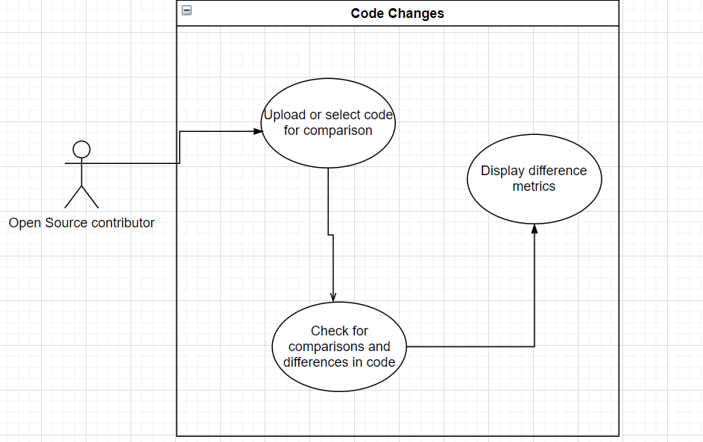

Activity Diagram:

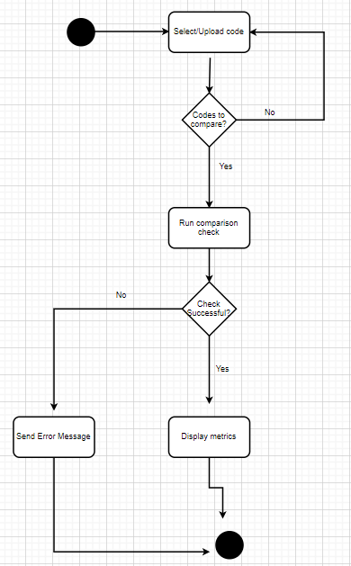

State Diagram:

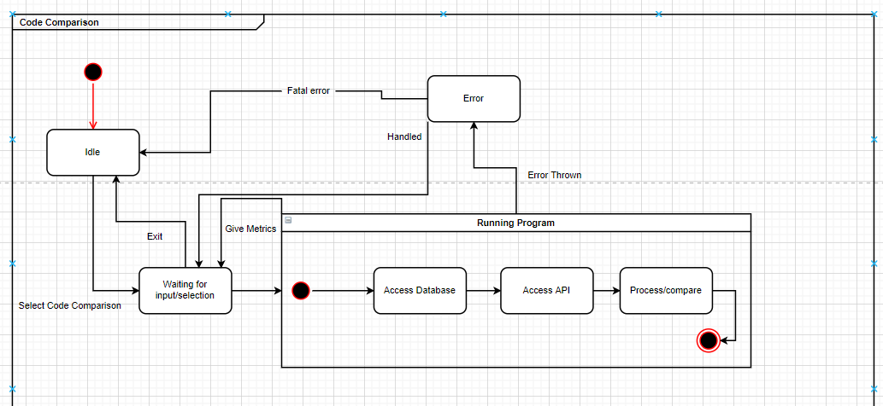

Sequence Diagram:

